INTRODUCTION
Welcome to the latest and most exciting update for the Spec Racer platform. The custom SADEV ST 75 transmission case took a little over 4 years of R&D with SADEV here in America and their parent company SADEV of France.
The sequential 6 speed transaxle adds a new dimension to SRF3, both from a reliability and obsolescence stand point heading in to the future.
Just like the Gen3 conversion you need to have good general knowledge of SRF maintenance, repairs, tools and equipment to perform this update.
Before starting the conversion process, take time to read these instructions completely. Confusion and time will be saved with an overview of the entire process.
Please inspect all of the parts when unpacking.
For the most part, the conversion is similar to changing a transmission with a couple of detailed updates.

SRF 3 SADEV Conversion Manual

Getting started:
First remove all the body and fiberglass seat. Thoroughly clean the car inside and out. Drain the coolant, engine and transmission oil. Note: it is possible to do the work with-out removing the seat.
Organize your work area as if you were going to do a clutch or transmission repair.
Place the car on stands. Disconnect the battery ground cable.
Remove the engine and transmission from the chassis. Remove the Ford OEM 5 speed shift linkage. Set aside the chassis attachment hardware.
Place the engine in a stable location where you can work on it.
Set the axles aside. You will need the outer CV’s and boots, unless you purchased new ones.
Disconnect the main EFI harness from the ECU and situate it in a way that you can work on the main ECU connectors. If you do not feel comfortable updating the EFI harness, please contact your CSR.
Your ECU will need a new tune file to perform properly with the SADEV transmission. There are a couple of ways to get this done, make an appointment with a CSR at a future event, ship the ECU to a CSR or SCCA Enterprises with a return address and form of payment for return shipping.
Note: The engine will run just as it did before the SADEV conversion. Flat upshift, discreet gear position and a stable speed signal will not be available without the wiring and tune file update.
Engine Prep:
Remove the clutch, flywheel and transmission adaptor plate from the engine block. This is easy to write, not necessarily easy to do. The adaptor plate is held in place with a series of counter sunk (flush) fasteners and a nut.
There are 3 fasteners threaded into the block and they can be difficult to remove. The surface area of the flush fastener vs. the area of the 6MM allen hex can be a problem.
I’ve had good luck with a hammer impact driver. Start by centering the tool and giving the fastener serval good hits with-out trying to move it in either direction. Then use the tool in the removal mode. Most of the time the fastener comes loose. Sometimes it helps to heat the block with a propane torch.
If you round out the hex, you can weld a large jam nut to the fastener, or you can drill just the head off of the fastener. It is 10mm X 1.5. If you choose the drill method, drill the head in a couple of size steps, doing your best to keep the drill centered in the fastener. The final drill size should be no larger than .394” (.394” is 10mm). once the head is removed you should be able to remove the threaded portion with pliers.
Take care not to damage the threads in the block.
Once all of the fasteners are out of the transmission adaptor, it should come off with little effort. Do not discard the adaptor at this point.
Now is a good time to inspect the clutch assembly. The flywheel step needs to be flat and at least .099” tall, new is about .102”
Check the disc. Make sure there are no cracks in the center drive plate and that the spines in the hub are in good condition. The friction material thickness should be .276” or more when compressed if it is a Kevlar disc.
The steel pressure plate under the clutch cover needs to be flat and at least .453” thick, new is about .457”.
Look at the spring fingers on the clutch cover. They should not be excessively worn. The total wear limit for all the clutch parts is about .030” to .035”
To ensure that you have no clutch problems, inspect the parts carefully. If you have doubts or concerns, please contact your CSR.
If all the clutch parts check out, or if you purchased new, you are ready for reassembly.
To install the flywheel, make sure the crank face and flywheel are clean, dry and free of imperfections. Torque the fasteners evenly to 45/48 ft lbs. using a little blue Loctite.
Using your favorite clutch alignment tool, torque the clutch cover fasteners evenly to 16/18 ft lbs. using a little blue Loctite.
Set the engine out of the way.
Transmission Prep:
When you unpacked your SADEV transmission kit, you should have checked for damage during shipping. Critical things to make sure are okay are the shift lock solenoid, shift barrel position sensor and both pigtails and connectors. Make sure they have not been smashed or cut during shipping.
Looking at the transmission from the gear case end, on the left side, there are 2 vertically aligned threaded holes. (Yellow plugs in them) These are the clutch hydraulic supply and bleed openings. The upper opening is the bleed and the lower is the supply. In the kit, you have a 17mm hex bleeder fitting (S691800 and G691805) and a -3 male fitting (S691903), both will use sealing washers (S1010102). Clean the threads and apply blue Loctite to both fittings, tighten to around 15 lbs. The release bearing is built into the SADEV case, we no longer use the Tilton release bearing.
You can also install the shift cable bracket (S302020) at this point, it uses a 10M X 1.5 allen socket cap bolt (installed in transmission) and allen socket cap bolt 8M X 1.25 (WM1010125)
You should also check both allen socket drain plugs on the bottom of the case. Check that you can loosen the plastic filler plug on the top of the case. It uses a rubber washer to seal and can seem very tight if the rubber washer is dry.
Remove the shift lock solenoid. Make note of the sealing washer and cover the hole with a piece of tape. You will reinstall it after the engine/trans assembly are bolted in the chassis.
Test fit the new gear box to the engine block. The alignment dowels are close tolerance, and are tight the first couple of times on and off.
If you have any problems with the clutch alignment, loosen the clutch cover bolts and realign the disc.
Set the gear box out of the way.
Axle Prep:
In your kit, you have two new axles (S392605 and S392606), two new inner tri-lobal drive cups (S700001 and S700002) with boots and clamps (S392610 and S392611). Note: a couple of parts not used, roll pin and SADEV boot clamp. They are part of the SADEV Kits.
You can reuse your old outer CV’s and boots, or you may have chosen to start off with new parts.
Either way, it’s best to build your axles in a bench vise with aluminum soft jaws.
Remove the outer CVs from the axles, start by opening the clamps. Slide the boot to the opposite side of the axle and wipe the grease away. You will see the tangs of an internal snap ring. Use a pair of flat jaw snap ring pliers to expand and with a soft hammer tap the CV joint off the axle. Remove the boot as well. Repeat on the second axle.
Clean and inspect both outer CVs. If they show any signs of pitting in the roots of the races, cracks in the cage or cuts on the balls, they should not be reused.
Take a look at your new axles. There are two different splines. We will build the axle from the smaller spline side.
First find the inner axle boot adaptors (S392609). Install them with the hardware (S1010110) inside the boot (it looks better that way). Measure about 145mm from the convex end of the larger spline end of the axle, mark with a marker. Fasten the boot adaptor angle edge on the mark you made. Blue Loctite should be used on the fasteners. You can use a little silicone to seal the gaps in the adaptor halves if you choose.
See picture
The 145mm measurement should keep the boot pleats from rubbing together when the axle is installed. If the pleats rub together when the car is underway, the boot will over-heat and can rupture prematurely.
Next you will need to pre-grease the 3 bearings of the tri-lobal. This can be done before or after you install the bearing on the axle with the provided snap-ring (inside the drive cup box). You can accomplish this in one of three ways: by using the palm of your hand to rub grease into the needles, by using a needle adaptor with a grease gun, or you can use a commercially available tri-lobal grease cup. Either way you choose, it’s important to pre-grease the needles.
Slide the inner boot over the small spline side of the axle and onto the boot adaptor. Looking at the two tri-lobal drive cups, one has a longer stud or spline than the other. The longer drive cup (S700001 - F90627041) goes on the short axle and the shorter drive cup (S700002 - F90627051) goes on the long axle.
This next step is a little tricky. In the bottom of the drive cup, there is a stiff spring that has a stamped steel cup on it. Make sure the spring is seated in the recess in the bottom of the drive cup and add a generous amount of Hi-Temp CV grease. You will need to compress the spring as you fit the axle assembly into the drive cup. The boot is the only thing that holds the assembly together. As you compress the spring with the axle, you will need to fit the boot around the outside of the drive cup. Do your best to keep the sealing surface of the boot free of grease. You can now install the large clamp.
I would not clamp the small end of the inner boot until you are sure the pleats of the boot will not rub together after the axle is installed i.e., move the boot adaptor on the axle in or out.
Grease and install the outer CV, boot and clamps (398105 and 398203) and set the axle aside.
Repeat for the second axle.
Note: There is no internal snap ring that holds the axle in the transmission like the OEM CV. The pressure of the spring pushes the axle toward the upright and in turn pushes the drive cup into the transmission when installed.
Chassis Prep:
You should have already cleaned the chassis completely and removed all of the shift linkage. If you have a Butler seat it can stay in place. If you have a fiberglass seat it may be easier to remove the linkage with the seat removed, or at least unbolted so you can access the pivot bar mount fasteners.
In your kit you have all the parts of the cable shift linkage. This includes the shifter chassis bracket (S1139252), gear shift lever (S1139250), shift cable (S302019), brackets and hardware.
First assemble the shift lever on the new shift bracket with the 1.75” X .375 -24 bolt (S1010103) and washers (10000414 and WM1010117) using blue Loctite. If you look at the plates on the bottom of the gear shift lever, they are beveled on one or both inner edges of the plates. If only beveled on one side, the bevel faces the rear of the car. Remove one of the lock nuts on the sifter cable threaded sleeve. Install it in the shifter bracket about in the middle of the threaded area, tighten the lock nuts.
Next attach the .250” X .250” female rod end (WM1011019) on the cable about in the middle to 2/3’s of the threaded area, tighten the lock nut. Attach the rod end to the bottom of the shift lever with a 1.250” X .250”–28 bolt (S1010106) two washers (1000410) and a nut (1000392). Check to make sure the lever moves freely.
Route the cable where the old linkage passed into the engine compartment. Finally bolt the assembly back to the chassis with the old fasteners. You can reinstall the seat as well. In the engine compartment, looking forward from the rear of the chassis, place the shift cable in the upper left side of the chassis, it will be on the left side of the engine when finished.
Note: leave the cable loose and free to move around. The bends need to be as gentle as possible so that the cable moves freely.
Next we need to make sure the 1” diagonal chassis tubes that are under the engine and transmission are straight. It’s pretty common for one or both of these bars to be bent up. This occurs from running over curbs, going off course etc. The SADEV case is a little larger in a couple of areas and more compact in a couple of areas. In the area of the main case halves, above the left diagonal bar it’s a little larger and we need all the clearance we can get. If either of those bars are bent up, you will need to straighten them.
Take a couple of minutes and look at all the engine mounts, making sure nothing is bent or cracked.
In your kit there are two pieces of hose, -12 (WM1010323A) and 5/16” (WM302023), a -4-bulkhead fitting and nut (S691900and S691901) and a -4 straight push on fitting (G691927).
Remove the crankcase oil catch bottle. This is a good time to clean it inside and out, as well as the filter. You will need to add the -4-bulkhead fitting to the catch bottle. Most bottles have a flat area near the -12 fitting already in the bottle, some do not. This is where the -4 fitting needs to go. Drill a new hole and install the bulkhead fitting. Make sure where you place the bulk head fitting, the -4 straight fitting could be attached to the bottle. The 5/16’s piece hose in your kit is the transmission breather line. If you look at the top of the trans case, there is a black plastic fitting, with two green buttons. If you depress the green buttons at the same time, you can remove the breather fitting from the case. Install that and -4 straight in the 5/16 hose.
There is also a piece of -12 hose (WM1010323A) in the kit. That is your new crankcase breather line, it should be a couple of inches longer that the old one. The breather hose needs to be pushed up against the fuel cell panel when installed between the engine & bottle. This way there will be room for the auto blip downshift cable and bracket. Make note of how the two -12 fittings are clocked compared to each other, remove them and install in the new longer piece of hose.

Included in your kit are the parts for a cable auto blipper (S1160001). This kit contains the following:
- 1 – S1010111 Hairpin
- 1 – S1010112 M6 x 1.0 Nut
- 2 – S1010113 10/32 x ½ Button Head
- 2 – S1010114 8/32 nylock Nut
- 5 – S1010115 Washer
- 1 – S1010116 6/32 x 3/8 torx Socket Head Bolt
- 1 – S1010117 PTFE O-Ring
- 1 – S1010118 Steel Pin
- 1 – S592301 Sadev Blipper Cable
- 1 – S610000 Auto Blip Body
- 1 – S610001 Auto Blip Body 2 – Threaded
- 1 – S610003 Auto Blip Puller Bracket at Shift Rocker
- 1 – S610004 Auto Blip Cable Bracket at Transmission
- 1 – S610005 Auto Blip Cable Bracket at Intake
- 2 – S610006 Cable Adjuster
Start by assembling the tear drop cable puller on the barrel of the braided cable. One half of the cable puller (S610000 and S610001) goes on each side of the brass barrel with the Teflon O-ring (S1010117) in-between them and held together with the #6 32 fastener (S1010116) and blue Loctite. See picture
Attach the cable bracket to the throttle cable bracket. See picture. You will use the preexisting hole and you will need to drill a .201” hole in the throttle cable bracket. Drill the hole so the blipper cable is in line with the throttle cable. See picture
Install one of the cable adjustors (S610006) in the bracket with the cable recess pointing toward the ground. Tighten the adjustor nut and stud to the bracket with blue Loctite and cut the extra threaded area off the adjustor. Deburr the hole. Route the throttle cable brass barrel through the Teflon O-Ring and route the blipper braided cable through the cable adjustor. This can be set aside for now. We will finish the assembly when the engine and transmission are in the chassis.
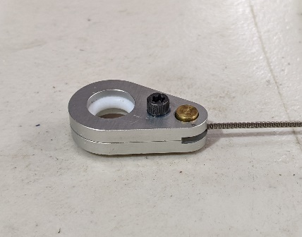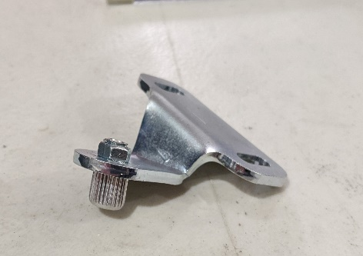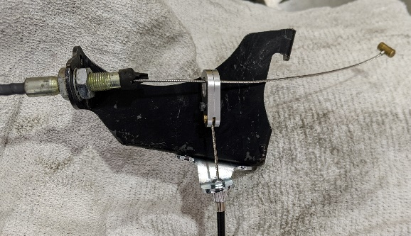

EFI Wiring Update:
In the kit are two wiring update harnesses (S1190001 and S1190002), a lock-out push-button switch (S302030), bracket (S1130200) and two shift lock decals.
The 8-wire update harness is to provide necessary SADEV / ECU signals. This will make the transmission full throttle or flat upshifted, a “gear position” added to the data stream to be displayed on a dash, also added to the data stream, stable “speed” signal. The 2 wire update harness is to activate the shift lock solenoid.
You should have already removed the center section, harness ty-wraps and main connectors from the ECU so the harness is in a relaxed position. In most cases you can do this update above the ECU mount location.
Remove the orange pin lock from both connectors. The “M” is the larger 34 pin connector and the “C” is the smaller 26 pin connector. The small tabs at the end of the orange pin lock are fragile, use care and gently bend them away from the center of the connector, one end at a time while gently lifting the lock away from the connector body. To identify the wire locations, the connector bodies have a number at the end of each row of wires. Counting from a numbered location is the only way to identify the pin/wire location you need to work with.
You will need a de-pin tool of some kind. I use a Lisle #14900 generic GM tool, it has .020” X .060” rectangle probe. I have filed the end like a wood chisel so that it will grip the lock tang with almost no pressure. See pictures of the tool and connector lock tangs.
Once you have engaged the lock tang in the connector body, gently pry it away from the socket of the wire you need to remove. NOTE it works best to gently push the wire into the connector body while unlatching the lock tang, then gently remove the wire from the connector body. Make note of the socket orientation. The socket will fit in the connector in only one direction.
You will also need to remove a couple pin plugs (C-16 / M-19 locations). These can normally be extracted with a small pic or a very small pair of needle nose pliers or tweezers. If you are very careful you can push the pin plug out from the ECU side of the connector body with a piece of .023 safety wire. NOTE Never push the pin plug into the connector body!
Once all the update wire locations and plugs are removed, (see below) lay the SADEV update harness alongside of the main trunk of the EFI harness. At this point you can lightly ty-wrap it to the main harness.
There are 8 loose wires: 2 Orange, 1 each of Brown, black with a white tracer, white, yellow, green and a purple.
The white, green, yellow and purple wires are new signals needed, 1 orange is 5 Volt ECU supply and brown is reference 0 Volt / signal return.
The second orange & black with white tracer wires that have male pins, are to be connected to the M16 & M26 sockets you removed from the M connector body. Orange to orange and black with white tracer to black with white tracer. Make sure they are fully seated in the sockets and tape or heat shrink those connections.
Note: these connections are the new 5 Volt and Ref 0 Volt for all the EFI sensors...make sure they are secure.
When you have made all the updates to the harness, it’s a good idea to double check the pin locations, install the orange pin locks and reconnect both ECU connectors.
Secure the update harness to the main EFI harness and connect to the SADEV sensors. Secure loose or slack wires in a safe manor.
There is also a gray DTM connector on a short lead near the ECU, this connector is Analog #4, possible update in the future.
Now the Neutral / Reverse shift lock wiring. Lay the wires on the main EFI wiring as you did with the first update.
Next attach the red wire eyelet to the unswitched side of the IGN switch. That way anytime the master switch is “on” you can shift the car from 1st to Neutral or Neutral to reverse. The black wire eyelet needs to be grounded, I drilled and taped a 10/32 hole in the chassis near the IGN switch. It can be grounded in any secure location in that area.
There are also 2 female spades, those are to be connected to the push button switch that was provided in the kit. That switch must be mounted on the supplied bracket hanging from the roll bar or on the left end of the dash.
The reason for this, we need consistency for corner, grid and emergency personal to be able to find the switch. There are also 2 decals in the kit.
A switch ID decal to be placed near the switch and a general switch location decal to be placed on the body near the switch.
Secure the neutral / reverse lock–out wiring to the main EFI harness and connect it to the solenoid on the transmission once the transmission is installed in the chassis.

Reminder, our rules, when there is an update to the car and specific locations or procedures are written, they are enforceable.

Wires to remove / update
M-14 White / Speed OEM pulse generator / not used / fold back and cover
M-16 Orange / Ref 5 Volt supply / connect to orange wire with flat pin
M-23 White / Black tracer / Knock sensor / not used / fold back and cover
M-26 Black / White tracer / Ref 0 Volt return / connect to black with white tracer with flat pin
C-16 Remove plug
M-19 Remove plug

SADEV Update Harness Pin out
Terminal Type Color Location
ECU female socket Orange M-16
ECU female socket Brown M-26
ECU female socket Green M-23
ECU female socket Yellow C-16
ECU female socket White M-14
ECU female socket Purple M-19
Flat pin Orange Female ECU socket Orange
Flat pin Black w White Female ECU socket Black w White

Pin out of the new connectors
SADEV 3 Way / Gear Position sensor
A Ref 5 Volt orange
B Ref 0 Volt brown
C Signal M-23 / Analog #6 green
SADEV 2 way / Flat shift switch
1 Ref 5 Volt orange
2 Signal C-16 / Digital #3 yellow
DTM 3 way / Speed sensor
1 Ref 5 Volt orange
2 Signal M-14 Digital #1 white
3 Ref 0 Volt brown
DTM 3 way (near ECU / future)
1 Ref 5 Volt orange
2 Signal M-19 Analog #4 purple
3 Ref 0 Volt brown

Lisle tool #14900
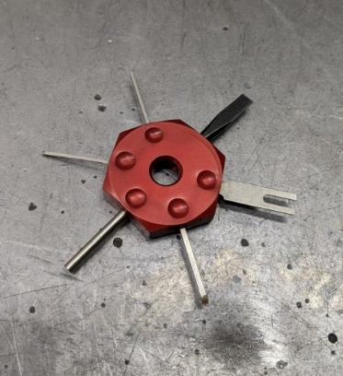
Connector wire location numbers
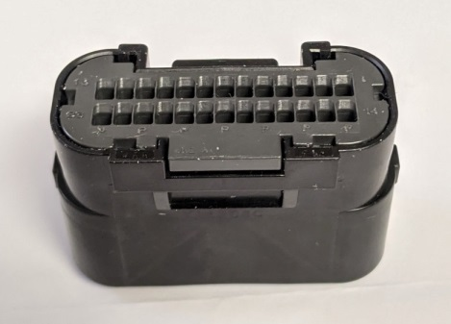
Socket and lock tang in connector body.
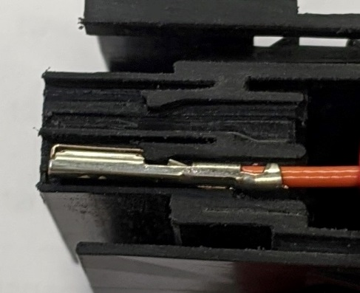
Unlocking the tang.
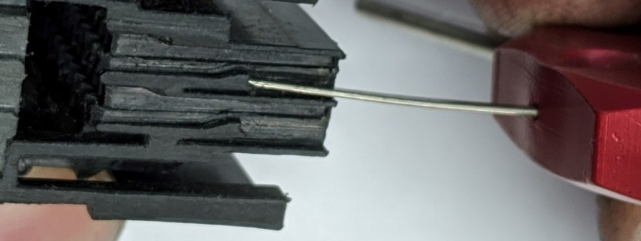
Connector ID’s
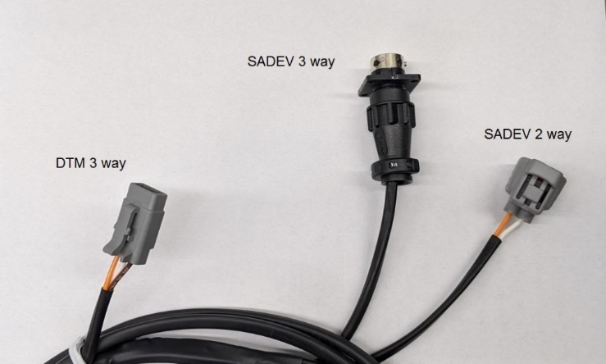
Let’s move on to Engine / Transmission assembly.

Engine / Transmission assembly:
Hopefully, when you preassembled the trans to the engine it fit without problems.
In your kit, you have all new transmission to engine fasteners and a steel shim plate. Also, upper and lower transmission mounts, new mounting fasteners and a pair of shims for each mount.
The steel shim plate goes between the engine and trans case to prevent galling or metal transfer between the 2 aluminum parts. It is also figured into the stack height of the clutch release bearing, also acts as a dirt shield for the bell housing.
The new transmission to engine fasteners are various lengths, also the engine to transmission fastener closest to the drivers right Tri-lobal joint should be a socket head Allen. see picture.
In the future we will no longer cut the back of the OEM oil pans off, those locations will turn into structural mounting points. The SADEV Mid-adaptor is laid out with those in mind.
Note: the 3 threaded holes in the block, for reliability they need to have enough thread engagement, for example, the block 10M X 1.5 fasteners need 15 / 20 mm thread engagement.
Most of the R&D transmission owners have had good luck installing the engine/ transmission as an assembly. If you have a way to angle the assembly at about 45 deg from a cherry picker or other lifting device. With the transmission hanging down, began lowering the assembly into the chassis, gradually level the assembly as you lower it into the chassis.
The crank pulley will be in the right rear corner of the chassis area….as you level the assembly, the transmission moves under the upper 1.5” X 1.5” chassis tube, you can also move the crank pulley toward the fuel cell bulk head. Once the unit is close to where you can install the motor mounts, stop for minute and have a look at the new transmission mounts.
The new mounts install like the old mounts, however because of the close fit of the transmission case, we have provided shims to make sure the case is not resting on the chassis.
Start by setting the new transmission mounts in the chassis. Use the lifting device to hold the engine assembly close to proper height. I start with the mount closest to the alternator, then the upper transmission mount, rotate assembly back and forth to line up the lower transmission mount and finally the end of the cylinder head mount. With all the mounts snug, check the clearance at the 1” diagonal tube of the left rocker tab and the lower diagonal 1” tube under the transmission. If you need to add or remove a shim to gain the most chassis clearance, now is the time to do it.
If for some reason you cannot obtain clearance, we have both types of shims for both mounts in stock.
Note: some R&D cars had problems with the lower transmission mount fasteners coming loose, blue Loctite is recommended. The lower bolt of the bottom mount is difficult at best. Use care starting the fastener into the transmission case.
Once you have good clearance, tighten all the mount fasteners.
Next install the axles, this can be a little tricky, some R&D teams could pull the upright up and compress the spring of the inner Tri-Lobal joint and insert the outer CV joint in the hub. Others removed the upper ball joint to insert the outer CV joint in the hub. Be careful not to over articulate the CV joint and pop a ball out of the cage. Reattach the uprights, both ball joints and toe link, you need to check axle plunge, this is very important before you snug the axle nuts.
With the uprights attached, with-out the axle nut on the CV joint, push the axle straight in toward the transmission, this is axle plunge. If you are using around 4.5 deg of negative camber, you should have around 10 to 16 mm of plunge. If you have more camber, it’s a little more if you have less camber, it’s a little less. If you have less than 6MM you could have a problem under full corner load. We have a limited number of shorter axles, contact your CSR.
Don’t forget to torque axle nuts once the car is on the ground.
Now is a good time to install the shift solenoid, connect all SADEV connectors, arrange and secure the new wiring.
Now route the new transmission breather hose, check the fit of the new crankcase breather hose tighten the fittings
Now attach the clutch supply hose, bleed and check for leaks.
Now is a good time to add gear oil, filler plug is in the top of the case, it’s an off-white plastic filler plug. 1.8 Q if it’s dry and 1.6 after and oil change.
Now attach the shift rocker & cable.
Start by attaching the shift cable to the cable bracket previously attached to the transmission, you need 2 10-32 Allen socket head fasteners, cable clamp & shim and the second auto blip cable bracket.
Many people have screwed the 10-32 fasteners up from the bottom of the shift cable bracket, then stack the parts in this order, blipper cable bracket, cable shim, cable housing and last the cable clamp, secure everything with 10-32 nuts. You can also install the 10-32 Allen fasteners from the top down and the 10-32 nuts under the shift cable bracket. I would not rely on the threads in the cable bracket only.
Now we need to assemble the shift rocker, the stand that holds the rocker is made of 3 parts, base plate, right side support that attaches to the base with 2 6m X 1.0 flush fasteners and the left support that is a spacer with a through hole.
The base plate attaches to the transmission case with 3 fasteners, 8m X 1.25 X XX, Allen socket head, 8M X 1.25 X XX Allen socket head and 8M X 1.26 flush fastener. See picture
The shift rocker itself should already be assembled, it attaches to the stand with a 6M X 1.0 X 25 Allen socket head and the long 8M X 1.5 X xx fastener mentioned above.
Now attach the second .250 X .250 female rod end to the shift cable, with the supplied .250 X 28 X 1.250” bolt attach the rod end in the top of the shift rocker, check the angle of the shifter in the cockpit of the car, it should more or less be about straight up and down. If not use the female rod ends to adjust static position of the shift lever. Once adjusted tighten the rod end jam nuts.
Now add the rocker extension auto blipper cable attachment bracket under the head of the .250 X 28 X 1.250” bolt and tighten with a nyloc nut.
At this point you may or may not have the intake manifold on the engine. If you do, you can start the final assembly of the cable auto blipper and adjustment.
If the throttle cable bracket is attached to the throttle body, slide the cable housing over the braided cable, install the second cable adjustor with the cable recess toward the front the car in the in the bracket that is under the shift cable housing shim.
Adjust it about in the middle of the threads. Next insert the braided through the adjustor and lightly pull the slack out of the cable.
Next assemble the barrel cable clamp in the clevis and insert the braided cable in the lock. See picture
Next attach the clevis to the rocker extension bracket with the pivot pin and e clip.
Now everything is loosely assembled, we need to get all the slack or free play out the throttle cable, with-out preloading the throttle plate. You will likely need to move all of your throttle cable adjustments to do this, once that is done, again lightly pull the slack out of the blipper cable, make sure the blipper cable housing is seated in the cable adjustors.
Next lightly tighten the barrel cable lock on the braided cable while keeping the slack out of the cable.
Next you will need to use a PC and PE Monitor, or your data system throttle position reading to finish adjusting the blipper cable, pull the shift lever to the rear of the car 2 times. You may need to roll one or both rear wheels to make sure the transmission goes into second gear.
Next the push the shift lever forward as to down shift one gear, hold the shifter in that position…check the throttle position.
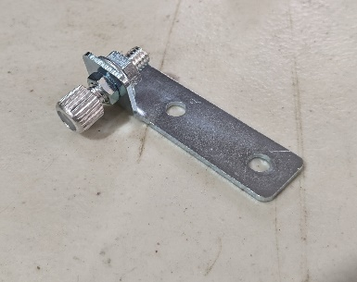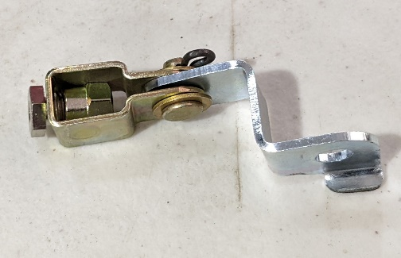
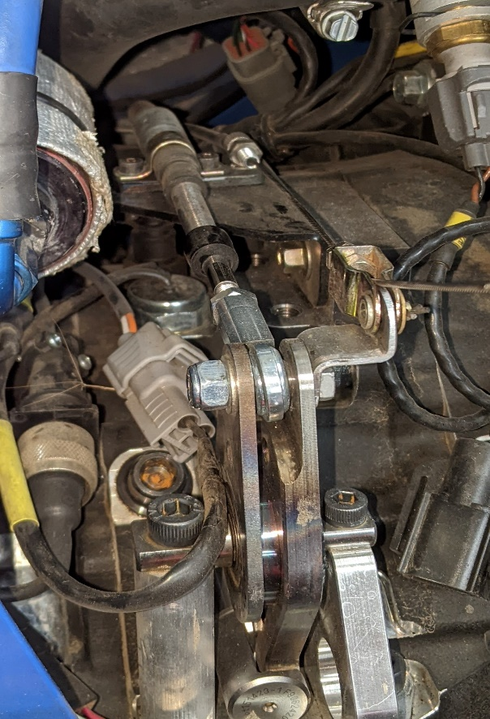

The TPS or throttle position needs to be between 35 & 40 % at the full downshift stroke. That opens the throttle about 16/20% that free the transmission of most of engine braking load.
Adjust the blipper cable as needed to achieve this adjustment. Remember to up shift a gear before pushing the shift lever in the down shift direction and holding to check the reading. Once you are close, you can use track data to make any final adjustments.
Note: Whenever shifting the transmission with the engine no running, it may be necessary to roll one or both rear tires so that the transmission will go in and out of any gear.
At this point you are done with the new assembly details, finish the assembly as normal.
Be sure and fill all fluids and check for leaks, always idle the engine up to temperature a couple of times to make sure the cooling system is full.
Also, it is best to double check the clutch pedal travel and clutch release, just as before, you only need about .375” pedal pad travel after the clutch disengages. The pedal pad movement should be about 2.5” after the slack is taken up. Adjust the pedal stop as necessary.
To take full advantage of the transmission, the ECU needs a new map or tune file. PE Monitor V50 is required. V50 does not have “SRF Display set up” utilities. That being said IAC problems or adjustment are going to be more cumbersome. If your ECU was a V37, you will need to install V50 monitor on your PC.
This is the link, http://pe-ltd.com/assets/pe3MonitorInstaller_v3_04_50.zip during or after install remember to allow V50 past all firewalls.
If your ECU was a V37, when it is updated to V50 it’s a fresh start, you will need to set the TPS open / closed and establish an IAC off set.
The easiest way to do this, place a small ty-rap under the throttle stop set screw, let the engine run at 1800 / 2000 RPM to warm up, at 200 F turn off the engine and remove the ty-rap. Make sure the ECU was power cycled. Restart the engine and let it idle, it should establish an IAC offset in 10 or 15 seconds.
You can download ECU data to check the IAC offset or hold the throttle just off idle for 10 or 15 seconds and let go abruptly, if it idles it’s likely set the offset, if it stalls, try the procedure again.
3 key things to set IAC offset: TPS zeroed at idle position, coolant temp 200F, power cycle so it clears the time window to set IAC, 3 conditions for the IAC offset to take place.

Basic care & operation of the transmission:
The SADEV is a pure motorsport product, it will need maintenance on a mileage schedule.
This has not been established at this point, but as long as the driver and transmission are in sync, it’s very likely to go 5000 miles between inspections. This of course will be determined over the next 3 or 4 seasons.
Proper shifting technique & oil changes are key to a long life. There is not an internal filter, all fine particles of metal are constantly flowing through gear faces and bearings.
The SADEV Transmission is a spec sealed unit, just like the OEM Ford / Mazda transmission. Missing / broken seal procedures out-lined in the GCR apply.
Inspections can be done by the car owner; arrangements must be made with a CSR for verification inspection and resealing of the transmission.
Emergency inspections at an event will be less of a problem if a CSR is present.
It is the responsibility of the car owner/driver to ensure proper seals are in place.
How to operate the SADEV
To select 1st, Depress the clutch, pause for a couple seconds and pull the shifter back (towards the rear of the car) quickly. If nothing happens then the lugs are not aligned and it will not go into gear, simply release the clutch to get all of the parts moving again, depress the clutch and try again. The timing may change just a touch between first thing in the morning “cold” in the middle of the afternoon “warm” or leaving the pit lane at the end of a session “Hot”.
Also, when the transmission is cold it’s normal for the transmission to be nearly silent and a little noisy when fully up to temp.
To select “neutral” when you come into the pits or park in your paddock space. Come to a stop, depress and hold the clutch, push and hold the shift lock button, then push the shifter forward about half of a normal shift stroke or motion.
The same goes for neutral to reverse, depress and hold the clutch, push and hold the lock out button, pause for a couple of seconds push the shifter forward about half of a normal shift stroke or motion.
Common mistake while learning the feel and motion of the shift lever. Coming to your hot pit location or to your paddock, you depress the clutch, push the shift lock button, push the shift lever forward about a full downshift stroke and select reverse while still moving forward. The transmission will go from 1st to reverse when you hold the shift lock button down.
So, until you have a good feel for the shift lever motion use care selecting neutral or reverse from 1st gear.
If you have ever ridden a motorcycle, think about the half motion from first to neutral, it’s a little touchy.
Note: severe transmission damage can accrue if you select reverse while moving forward more than a 1 or 2 MPH. Best practice is to come to a stop before selecting reverse. Also, if you are stuck in a gravel and one or both rear wheels are not in contact with the ground. Stop the turning wheels before selecting reverse.
Upshifting, in general, it’s best to upshift with a very quick motion, trying to be gentle with the shifter will likely cause more damage. If you feel multiple clunks in the shift lever when you upshift, something is not right.
You could be shifting to slowly or there is something wrong with the flat shift system.
A word on the flat shift tuning, it is not adaptive, it’s programmed and it does the same thing every time. The driver needs to adapt to the system.
If you run into the rev limiter before you pull the shift lever for an upshift, that disturbs the flat shift fuel cut and it may or may not shift cleanly.
During 2021 R&D season flat shift tuning was adjusted to be a kind of happy medium for everyone.
Also, when upshifting, take your hand off the shift lever when you complete that shift, do not touch shift lever until ready for another shift, shift lever movement triggers the flat shift switch, the switch is very sensitive.
If the system fails during a session or at an event, all is not lost, you simply need to lift off of full throttle, maybe ½” of throttle pedal travel in time with pulling on the shift lever to upshift.
This may take a little practice, but a small quick lift is how most dog ring transmissions are shifted. The key here is, what you feel in shift lever and what the acceleration of the car feels like. When it is done right, it’s close to seamless.
Another word on upshifting, this hasn’t been that common, but has happen several times already. For some amount of time, you need to be very present while learning the sequential transmission. All upshifts are pull back and downshifts are push forward on the shifter.
For whatever reason everything is going really well, then you feel comfortable and start racing with cars on the track, maybe you look at someone along the fence or pit lane. You may be in 2ed or 4th gear, muscle memory takes over. Next thing you do is push the shifter forward when you really needed to pull back for an upshift. Just like a missed shift with OEM H pattern transmission, it’s a big over rev.
Downshifting while under way around the track is same in opposite direction, give the shifter a quick push forward, the key is, you need to take the engine braking load off the transmission.
You can do this with a blip of the throttle in time with the motion of the shifter. You can rely on the cable blipper system or if you are in good timing with the transmission and decel rate of the car, you can downshift without doing anything. Just push the shifter at perfect time in the brake zone.
Having said that, if the timing is wrong without taking the load off the transmission… you can do significant damage to dog rings and gear sets. The same applies to up shifting poorly.
Safest thing to do, is learn to blip….
A word on the “Cable Auto Blipper” …it’s a very basic set up, it will work for those who do not learn blip timing. It is just a cable attached to the shift rocker on the transmission, when you push the shift lever forward for a downshift, it pulls the cable and in turn pulls on the throttle cable. When the cable is adjusted properly this simple system is very effective at removing the engine braking load on the transmission.
The bad part about the system: anytime you push the shift lever forward it makes a throttle blip. SO, when you select neutral and or reverse it makes a throttle blip. This can be annoying.
In the future when the throttle by wire is perfected, we will be able to eliminate the unnecessary throttle blips.
One more word on downshifting, a couple of common mistakes while learning to drive with a dog ring and or sequential transmission.
Let’s say you are headed down a 5th or 6th gear straightaway, approaching a 2ed or 3rd gear corner. You may need to make 3 or 4 gear changes. It’s very common to push the shifter 3 or 4 times very quickly forward as soon as you apply the brake pedal. While this is not a big deal to the transmission as long as you take the braking load off by blipping. You can seriously over-rev the engine. It takes a little presence of mind to spread out the gear changes so you do not over rev the engine downshifting.
If it’s a 3-gear down shift brake zone, pause when you apply the brakes, spread out the gear changes so you make the last one a couple of car lengths before you turn in for the corner.
Another common mistake is using the clutch to down shift, while this may seem like a good idea, it’s really not. When you disengage the clutch, the input shaft rotation starts slowing down very quickly. With each downshift you need the opposite, the input shaft needs to speed up. The lugs on the dog ring and lugs on the gear engage with a greater impact than blipping the throttle with the clutch engaged.

SRF3 SADEV Specs
SADEV Spec Ratio’s
FD 15-48 MPH
1 12-36 47
2 15-31 68
3 18-28 90
4 22-28 110
5 24-26 130
6 25-23 153
Gear Box Stack Order
R
5
4
3
2
1 Last gear before bearing plate
6 Gear under outer cover
Basic Torque Specs
Shaft bolts 60 lbs. SADEV Socket Needed part # XXXXXXX
8MM bolts 15 -16 lbs.
6MM bolts 6 - 7 lbs.
Lubricant
SADEV Recommends GL5 75W140
Oil Capacity
First fill 1.8 Q
Oil change 1.6 Q

Gear oil Change Schedule
SADEV recommends: After first day of track use and every 400 miles after
Shift Barrel Sensor output (volts) ECU channel “analog 6”
R 0.51 (Reverse reads “9” in the data stream, working on a fix for this currently)
N 0.84
1 1.15
2 1.80
3 2.45
4 3.07
5 3.72
6 4.37
If adjustment is necessary, contact your CSR
Power Shift Switch is calibrated by SADEV at the time of assembly.
If adjustment is necessary, Contact your CSR.
Switch must trigger between 1 to 2 mm of shaft movement (1.5mm or .060”) is the target.
Speed Sensor
The sensor reads the ring gear teeth / there are 48 per revolution
OEM VS SADEV MPH @ 6750 RPM
Ford OEM / Straight Cut SADEV
FD 20-77 MPH MPH
1 12-41 34 47
2 19-35 63 68
3 24-31 90 90
4 29-28 121 110
5 31-24 152 130
6 N/A 153

